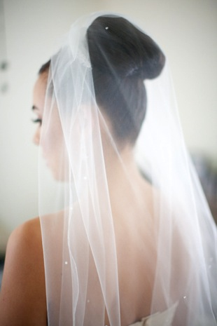
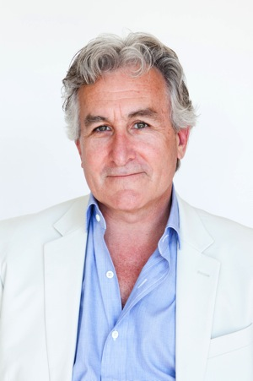

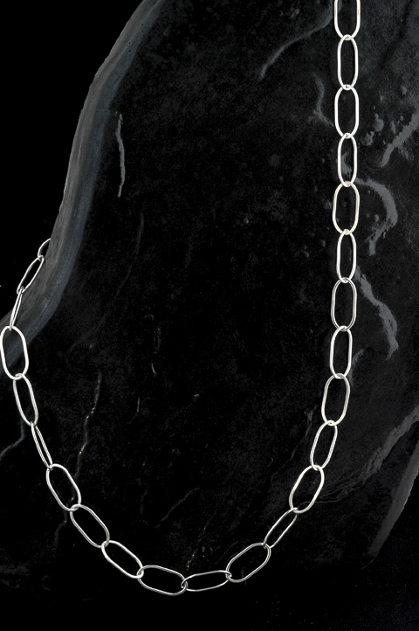
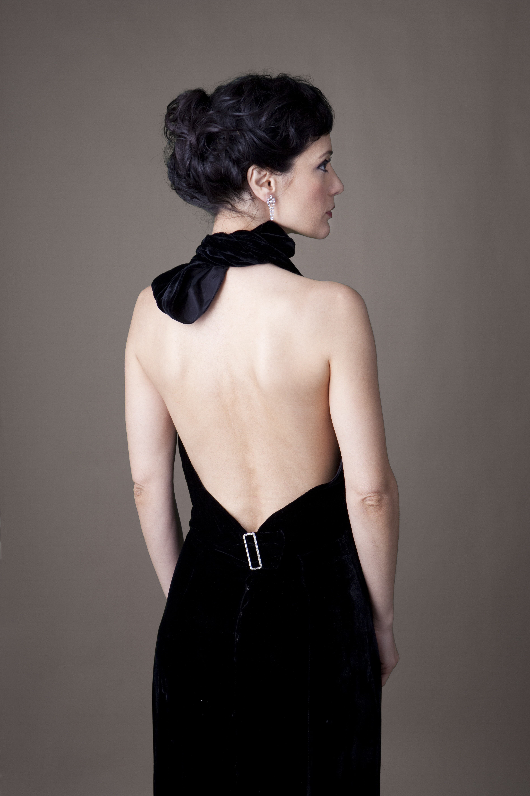
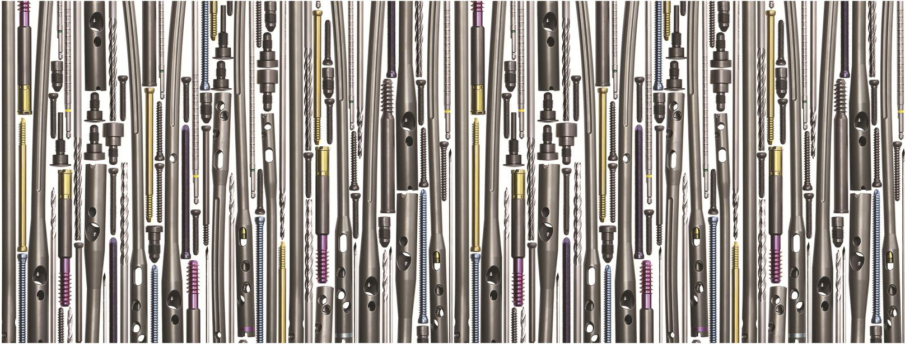
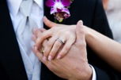
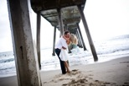
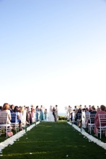
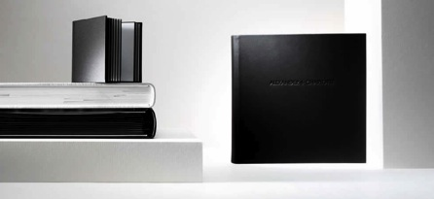
  - A Simple combination of Elegance & Light

Sara Jordan Photography

About

Intro
When you ask Sara about why she got into photography she simply answers “I wanted to take great photos of my friends!” Sara has been taking photos as long as she can remember. She has been awarded, published and exhibited many times. While attending the prestigious Brooks Institute of Photography in Santa Barbara, Sara was honored to be exhibited at The Photographers Hall of Fame alongside some of top photographers in the world. After college she worked for many top fashion and celebrity photographers. Considered a master photographer Sara’s Imagery tells a vibrant story. Her photography is a simple combination of elegance and light. Her work is subtle and delicate. A high-end photography service, she merges classical portraiture with unobtrusive photojournalism.

Thank you so much for contacting Sara Jordan Photography. Below you will find information about the services we offer. We’d also like you to know that we take unparalleled care when it comes to photographing your story. We use professional equipment, carry ample backup equipment and after every shoot we backup the images in 5 different places. If you have any questions or would like to set up a meeting please contact us anytime.
  - $400.00
  - $500.00

Must be done with in the first two weeks of giving birth.

Newborn Session
  - $400.00

Includes all edited digital images from the session

Maternity

Capture all the changes in your family over the years. Includes all the digital files.

Family Sessions
  - $300.00

Corporate headshots, acting headshots, senior portraits, online profiles,

Portrait Session
Portrait Services
  - $45.00

Per hour

Retouching all edited digital images from the session, 5 retouched digital negatives and an online gallery.

Full Day

8 hour shoots
  - $1,400.00
  - $700.00

Half Day

4 hour shoots
Commercial DAY RATE INCLUDING PRODUCT Photography
$500 first hour $350 each additional hour

Wedding coverage includes all the digital files and some minor retouching.

Engagement Sessions
$500.00

Second Photographer
With a second photographer you get multiple angles, more coverage including grooms prep and cocktail hour.
A unique twist on a photo booth… it’s more like a high fashion studio set up with professional seem-less back drop and strobe lights.
They say, don’t judge a book by its cover. We agree. Judge a book in its entirety. An album like a book is an imaginative journey, which unfolds in your hands.

Every Queensberry album is treated exclusively
As one of a kind. A unique sensory experience.
The touch of beautiful paper. The smell of luxury leather.
Personalized for your memories.
Excellence in. Every thing we do is the Queensberry way. Each album uses the finest materials sourced from all over the world. Each page you touch is one to remember.

Queensberry Albums
Wedding Services

Wedding Packages
Capturing your love before you say, “I do.” Engagement sessions are not limited by time or location. Each session includes all the digital files and some minor retouching.
$400.00
$1000.00

Photo booth

Sara Jordan Photography
1601 East Cesar Chavez,
Austin, Texas 78702
www.sarajordanphotography.com
info@sarajrodanphotography.com
Phone: (512) 696-8501

Additional Event Services
Media Board
5hrs of coverage, all images on a disk and an online gallery
$800.00

Mitzvahs, Qunceneras & Sweet Sixteen’s
6hrs of coverage 300 images on a disk and an online gallery
$500 first hour $350 each additional hr

Corporate Events
coverage, online gallery, images on a disk
$350 per hour

